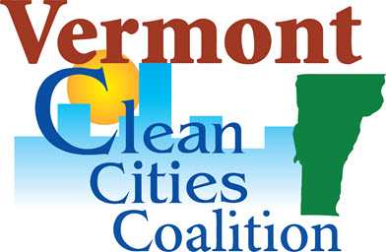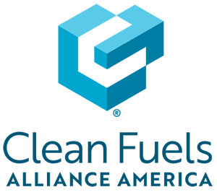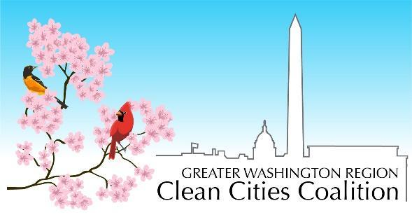

FOR IMMEDIATE RELEASE
October 13, 2023
Vermont Clean Cities Coalition Contact: Peggy O'Neill-Vivanco, Director, Vermont Clean Cities Coalition
Email: poneillv@uvm.edu

Greater Washington Region Clean Cities Coalition Contact: Antoine M. Thompson, Executive Director, GWRCCC
Office: 202-671-1580

Environmental Justice Community Forum Series (EJCFS) Addresses Critical Environmental
Issues in Underserved Communities

South Burlington, VT – Vermont Clean Cities, in partnership with the Greater Washington Region Clean Cities Coalition (GWRCCC) and Clean Fuels Alliance America (Clean Fuels) proudly announce the launch of the Environmental Justice Community Forum Series (EJCFS) - South Burlington, Vermont. This event is aimed at raising awareness and fostering dialogue on environmental justice (EJ) and the vital role of biodiesel in underserved or disadvantaged communities. The forum will be held on October 19 from 6-7:30 PM at 180 Market St Room 301, South Burlington, attendance is free and light refreshments will be provided.
What: Environmental Justice Community Forum Series (EJCFS) - South Burlington, VT
Where: 180 Market St Room 301, South Burlington
When: October 19, 6-7:30 PM
Registration: Free Event. Register here

The EJCFS campaign is running from August to the end of October 2023, with a series of community forum events and participation in key national conferences. Previous EJCFS events were held in Philadelphia and Washington DC and the series will be held in New York City, NY, Boston, MA, South Burlington, VT, and Camden, NJ as well.
The EJCFS aims to share the insights of the Trinity Study with stakeholders and community members in disadvantaged communities to build a national case for the role of biodiesel in environmental justice. The focus will be on raising awareness of the urgency to accelerate biodiesel adoption in disadvantaged communities. Considering the health-related consequences of diesel fumes, particularly on vulnerable populations such as children and seniors, biodiesel is a solution that can be implemented now to reduce the negative impacts of diesel emissions.
Many disadvantaged communities are not included in the growing conversations about climate change, despite often bearing the brunt of environmental disasters caused by climate change. Clean Fuels Alliance America and GWRCCC are eager to accelerate these conversations in response to the increasing climate crisis and its associated risks such as forest fires, extreme temperatures, hurricanes, and flooding while improving community health outcomes. The EJCFS Forum Series will begin the conversations necessary to ensure that no community is left behind in the transition to cleaner energy.
“I’m happy to be working with Greater Washington Region Clean Cities and Clean Fuels Alliance America on this community discussion about biodiesel in Vermont. Biodiesel is produced domestically, renewable and a substitute for petroleum-based diesel. As a drop-in, replacement fuel for heating, and for much of the year in Vermont’s transportation sector, biodiesel can help reduce NOx emissions and improve air quality in our communities - today,” remarked Peggy O’Neall-Vivanco, Director of Vermont Clean Cities Coalition.
"The EJCFS Forum Series is about sharing knowledge and building a case for biodiesel in environmental justice. We must urgently accelerate biodiesel adoption in disadvantaged communities to protect vulnerable populations from the health risks of diesel emissions. These communities have often been left out of climate discussions, yet they face the worst climate impacts. Together with Clean Fuels Alliance America, we aim to change that. The EJCFS Forum Series starts the conversations needed to ensure no community is left behind in our transition to cleaner energy," added Antoine M. Thompson, Executive Director of GWRCCC
Vermont Clean Cities Coalition (VTCCC), is a Department of Energy designated coalition working across Vermont to improve air quality and health, reduce environmental pollution, strengthen Vermont’s economy, and enhance our country’s energy security by working locally to advance affordable, domestic transportation fuels, energy efficient mobility systems, and other fuel-saving technologies and practices. https://vtccc.w3.uvm.edu/
Greater Washington Region Clean Cities Coalition (GWRCCC), focused on the Washington, D.C. metro area, is one of nearly 80 coalitions in the U.S. that fosters economic, environmental, and energy security by working locally to advance affordable, domestic transportation fuels, energy efficient mobility systems, and other fuel-saving technologies and practices. Find out more at https://gwrccc.org.
Clean Fuels Alliance America (Clean Fuels): Representing biodiesel, renewable diesel and sustainable aviation fuel, Clean Fuels Alliance America will advance the interests of its members by supporting sustainable biodiesel, renewable diesel and sustainable aviation fuel industry growth. Clean Fuels serves as the industry’s central coordinating entity for technical, environmental and quality assurance programs and will be the strongest voice for its advocacy, communications and market development. https://cleanfuels.org/

###

