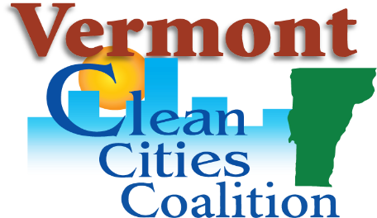
Earth Day Viewing and Discussion:
MOTHERLOAD

Monday, April 20, 2020

Sponsor/Vendor Invoice

Vermont Clean Cities is hosting a virtual Community Screening of MOTHERLOAD on Monday, April 20th to kick off Earth Week. The viewing will include a post-film discussion with film maker, Liz Canning, and V-Bike founder, Dave Cohen.
MOTHERLOAD is an award-winning crowdsourced documentary about a new mother’s quest to understand the increasing isolation and disconnection of the digital age, its planetary impact, and how cargo bikes could be an antidote.
The Community Screening allows the event to have an unlimited number of attendees. Your sponsorship will allow community participants free access to the film screening and the Q &A with the film maker.

CHECK PARTICIPATION LEVEL:
Level | Sponsorship Fee
____ Silver | $25.00
____ Gold | $50.00
____ Platnium | $75.00
____ Other

All Sponsors will be listed on promo materials. Please send your logo to: vermontcleancities@uvm.edu

Thank you for your support!
Sponsorship money will be processed by UVM Alumni Foundation and directed the Vermont Clean Cities Coalition programming. Please visit: go.uvm.edu/vtccc to process your sponsorship payment.

Organization/Business name: _________________________________________
Contact name: _________________________________________
Email: ______________________________
Telephone number: ____________________________

Questions? Contact:
Peggy O’Neill-Vivanco (VTCCC) at poneillv@uvm.edu, or Eliana Fox (VTCCC Intern) at
vermontcleancities@uvm.edu

